

**dE-VOTE**

## MINI PROJECT REPORT

***Submitted by***

|  |  |
| --- | --- |
| **NAGARJUNAN G** | **[20CS075]** |
| **SIVANARAYAN J** | **[20CS132]** |
| **SUGAVANAESH S** | **[20CS146]** |
| **THARUN KUMAR C** | **[20CS154]** |

**BACHELOR OF ENGINEERING**

## *in*

**COMPUTER SCIENCE AND ENGINEERING**

**SRI ESHWAR COLLEGE OF ENGINEERING**

**(AN AUTONOMOUS INSTITUTION)**

**COIMBATORE – 641 202**

**JUNE 2022**

**BONAFIDE CERTIFICATE**

Certified that this project report **“dE-Vote**” is the bonafide work of

|  |  |
| --- | --- |
| **NAGARJUNAN G** | **[20CS075]** |
| **SIVANARAYAN J** | **[20CS132]** |
| **SUGAVANAESH S** | **[20CS146]** |
| **THARUN KUMAR C** | **[20CS154]** |

who carried out the project work under my supervision

|  |  |
| --- | --- |
| …………………………………  **SIGNATURE**  **Dr. R. SUBHA M.E., Ph. D.,**  Professor & Head,  Dept. of Computer Science & Engineering,  Sri Eshwar College of Engineering, Coimbatore-641 202. | …………………………………  **SIGNATURE**  **Mr. B. SARAVANAN M.E.,**  **SUPERVISOR**  Assistant Professor,  Dept. of Computer Science & Engineering,  Sri Eshwar College of Engineering,  Coimbatore-641202. |

Submitted for the End Semester practical examination – Mini project work viva-voce held on ………………………

……………………… ………………………

**(Internal Examiner) (External Examiner)**

|  |  |  |  |  |  |  |  |
| --- | --- | --- | --- | --- | --- | --- | --- |
|  | | **TABLE OF CONTENTS** | | | |  | |
| **CHAPTER NO.** | | **TITLE** | | | | **PAGE NO.** | |
|  | | **ABSTRACT** | | | | **i** | |
| **1** | | **INTRODUCTION** | | | | **1** | |
| **2** | | **SYSTEM ANALYSIS AND DESIGN** | | | | **2** | |
|  | | 2.1 | | SOFTWARE DEVELOPMENT  LIFECYCLE | | 3 | |
|  | | 2.1.1 | | REQUIREMENT PHASE | | 3 | |
|  | | 2.1.2 | | ANALYSIS PHASE | | 4 | |
| **3** | | **PROPOSED SOLUTION** | | | | **5** | |
|  | | 3.1 Solution | | | | 6 | |
|  | | 3.2 OVERVIEW | | | | 7 | |
|  | | 3.3 BLOCK DIAGRAM | | | | 8 | |
| **4** | | **SYSTEM SPECIFICATION** | | | | **9** | |
|  | | 4.1 | | HARDWARE SPECIFICATION | | 10 | |
|  | | 4.2 | | SYSTEM REQUIREMENTS | | 10 | |
|  | | 4.3 | | SOFTWARE SPECIFICATION | |  | |
| **5** | | **PROJECT DESCRIPTION** | | | | **11** | |
|  | | 5.1 Methodology | | | | 12 | |
|  | | 5.1.1 Machine learning  5.1.2 Automation | | | | 12 | |
|  | | 5.2 Implementation | | | | 12 | |
| **6** | | **CONCLUSION** | | | | **13** | |
|  | |  | | | |  | |
|  | |  | | | |  | |

## ABSTRACT

Building a secure electronic voting system that offers the fairness and privacy of current voting schemes, while providing the transparency and flexibility offered by electronic systems has been a challenge for a long time. In this project, we evaluate an application of blockchain as a service to implement distributed electronic voting systems. The paper proposes a novel electronic voting system based on blockchain that addresses some of the limitations in existing systems and evaluates some of the popular blockchain frameworks for the purpose of constructing a blockchain-based e-voting system. In particular, we evaluate the potential of distributed ledger technologies through the description of a case study; namely, the process of an election, and the implementation of a blockchain-based application, which improves the security and decreases the cost of hosting a nationwide election.

**i**

**CHAPTER 1**

**1. INTRODUCTION**

Voting plays a significant role in a democratic society. Almost every local authority allocates a significant amount of budget on providing a more robust and trustworthy voting system. For voting systems based on the bulletin, one of the major concerns is whether the voting result that is published on the bulletin can be trusted. Blockchain with the growing popularity and remarkable success in the field involving cryptocurrency .

Blockchain was first introduced by **Satoshi Nakamoto** (a pseudonym), who proposed a peer-to-peer payment system that allows cash transactions through the Internet without relying on trust or the need for a financial institution.

**Decentralized applications** (dApps) are digital applications or programs that exist and run on a blockchain or peer to peer (P2P) network of computers instead of a single computer.

A **blockchain** is essentially a distributed database of records or public ledger of all transactions or digital events that have been executed and shared among participating parties. Each transaction in the public ledger is verified by consensus of a majority of the participants in the system. And, once entered, information can never be erased. The blockchain contains a certain and verifiable record of every single transaction ever made.

**e-voting** is a voting method that uses electronic means to either aid or take care of casting and counting ballots.

**CHAPTER 2**

**SYSTEM ANALYSIS AND DESIGN**

**2.1 SOFTWARE DEVELOPMENT LIFECYCLE**

**2.1.1 REQUIREMENT PHASE**

In the requirement phase, we collect users' unique Ethereum ID in which all the transactions are done. For casting a vote or to nominate as a valid candidate to stand in an election.

**2.1.2 ANALYSIS PHASE**

Analysis phase involves analysis of operational feasibility, technical feasibility and economic feasibility. The problem is worth solving hence it is operationally feasible. The solution is practical hence it is technically feasible. The problem is refined successfully until we have a complete cost-benefit analysis hence it is economically feasible.

**2.1.3 DESIGNING PHASE**

**Use case Diagram**

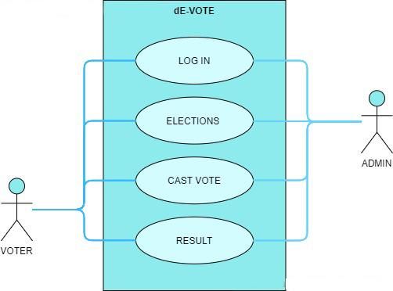

**CHAPTER 3**

**PROPOSED SOLUTION**

**3.1 EXISTING PROBLEM**

People from different locations (away from their constituency) might hesitate to vote as they should visit or proceed with postal voting. This might reduce the active participation of voters.

Moreover, conducting traditional voting is very costly and requires a lot of resources including people’s taxes. The traditional way of voting is centralized. Centralized data can be vulnerable to web attacks then can be manipulated easily. Even identity forgery could happen leading to manipulation of results.

Large section of demographic today do not trust their government.This makes an election a very crucial aspect in a modern democracy. The issue with the current Indian election system is that it can be manipulated and hence is not reliable upto a large extent. In recent times, we tend to use electronic voting machines.

**3.2 OVERVIEW**

In this paper, we propose a digital voting system that is completely built over blockchain protocol. Our voting system does not depend on a centralized trusted party for ballot tallying or result publishing.

Voting on Distributed Ledger Technology (DLT), or blockchain, provides an infrastructure that can facilitate trustless and secure transactions, or votes, on a network that users can reach anywhere. To create such a decentralized voting application that reaches people, we want to leverage an existing blockchain network that people can reach without the requirement of becoming a blockchain node. Ethereum provides tools to access blockchain nodes without the user becoming a node, specifically the MetaMask browser plugin. It is also a platform-independent system and provides comprehensive security assurances with the help of various cryptographic techniques.

In a nutshell, this system is going to overcome many of the issues faced by the current voting system.

**3.3 BLOCK DIAGRAM**

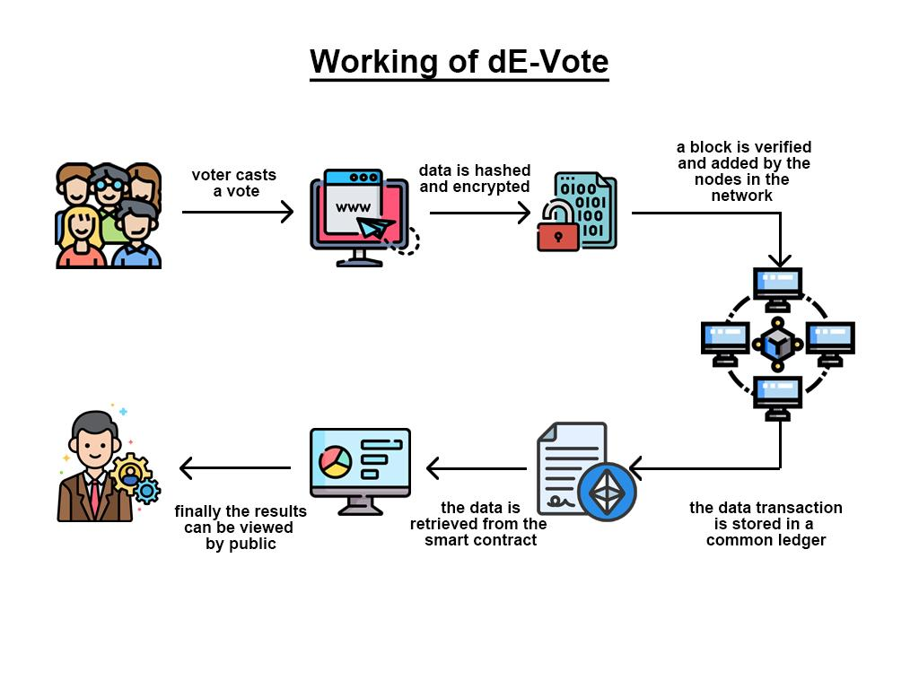

**CHAPTER 4**

**SYSTEM SPECIFICATION**

**4.1HARDWARE SPECIFICATION**

**RAM:** 4 GB

**PROCESSOR:** Intel(R) Dual Core CPU @ 2.5GHz

**4.2 SOFTWARE SPECIFICATION**

**OPERATING SYSTEM:** Windows, Linux, MacOS

**PROGRAMMING LANGUAGE:** Javascript, Solidity

**TOOLS & DEPENDENCIES:**

Web browser(Chrome, Mozilla, Safari),

Node.js, npm, React.js, Web3.js, Ganache-cli,

Truffle, Solidity, Metamask

**DATABASE:** MongoDB

**CHAPTER 5**

**PROJECT DESCRIPTION**

**5.1 PROBLEM DEFINITION**

The existing voting system is heavily time consuming and requires a lot of manpower to conduct and produce the results of a single large-scale election.

In this time consuming world every possible thing that requires time is not encouraged.User basically needs a faster voting system which requires less man power and work load.

To implement a secure and reliable way of organizing the voting we are using blockchain which produces users the capabilities of having a faster voting system and which cannot be tampered that much easily.

**5.2 CHALLENGES**

To implement this in the current situation the voters need a small amount of crypto currency to pay for the gas fee.

**5.3 DESCRIPTION**

A simple E-voting decentralized App using the Ethereum Blockchain, Solidity and the MERN stack.

Ethereum is an open source, public, blockchain-based distributed computing platform and operating system featuring smart contract functionality.

**CHAPTER 6**

**RESULTS AND SYSTEM IMPLEMENTATION**

**SCREENSHOTS**

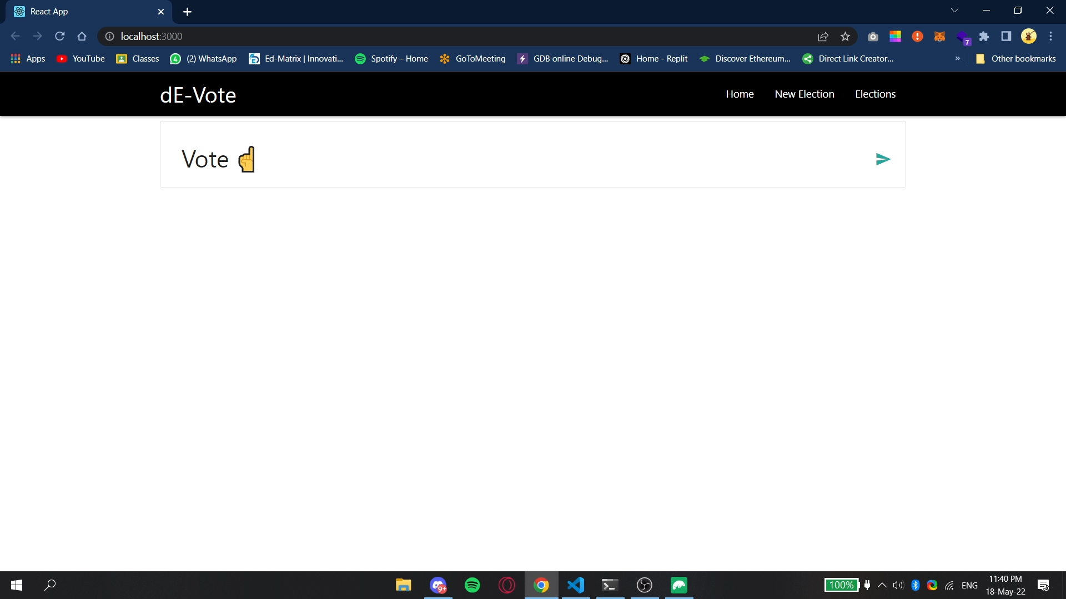

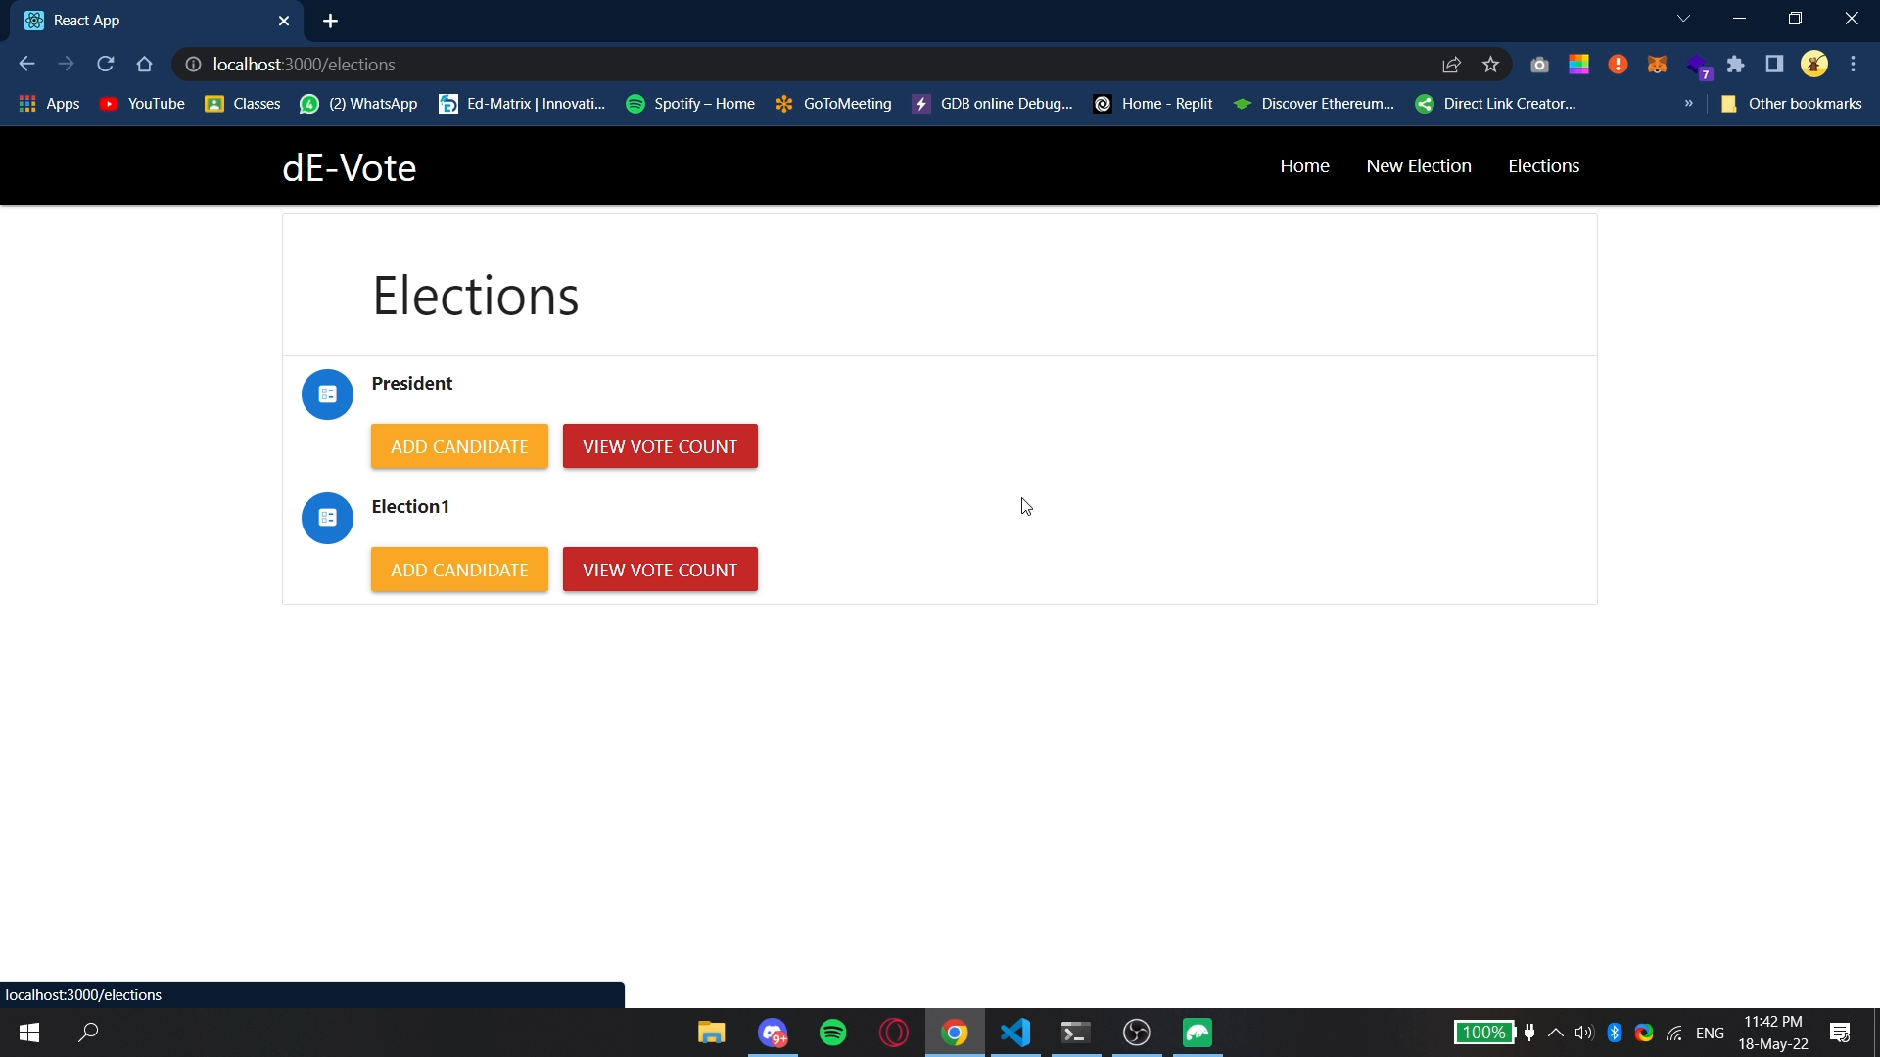

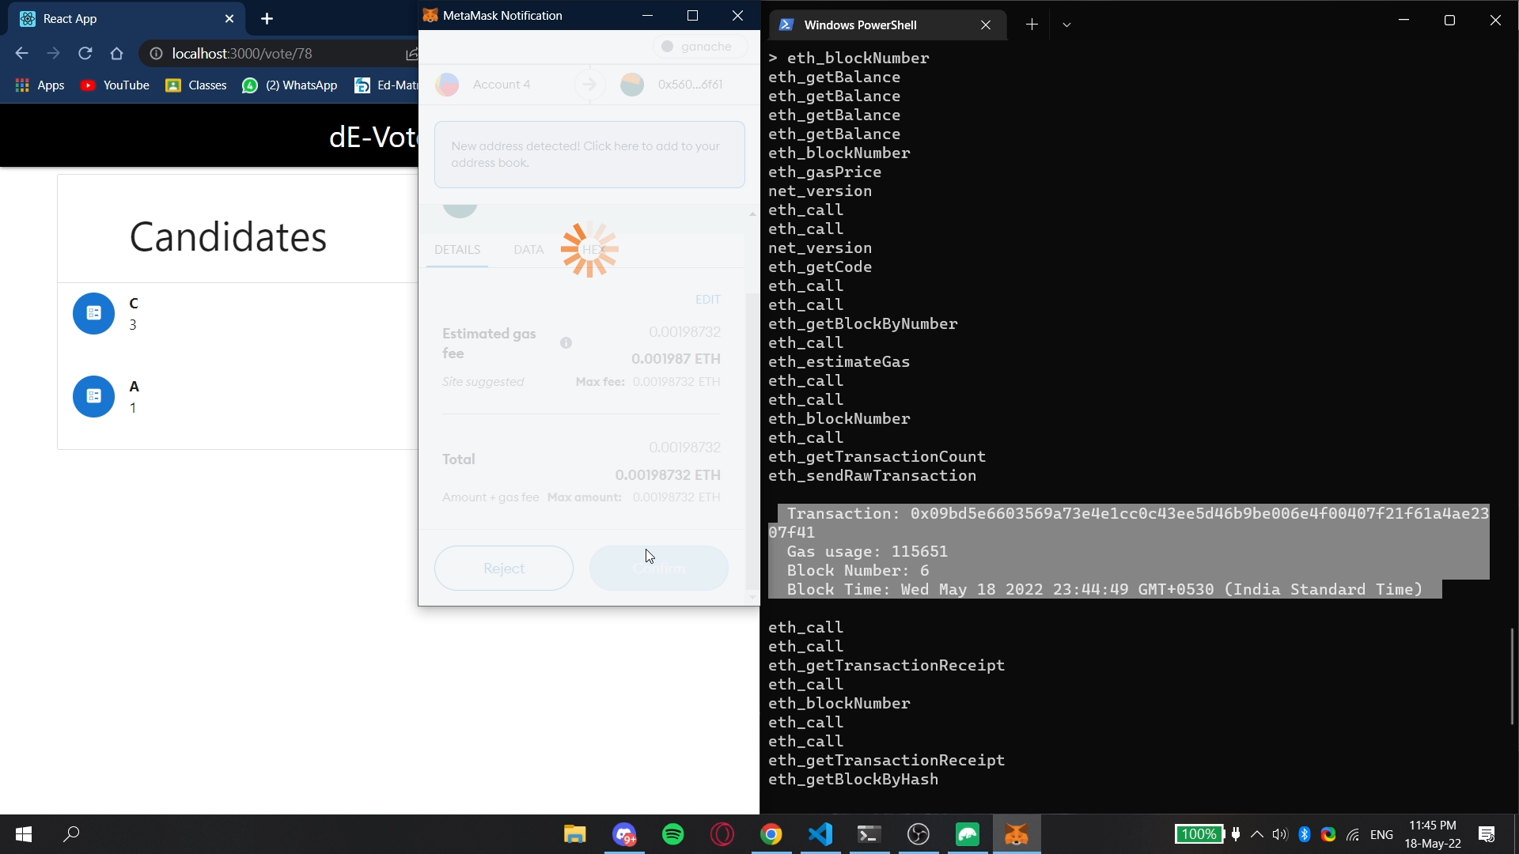

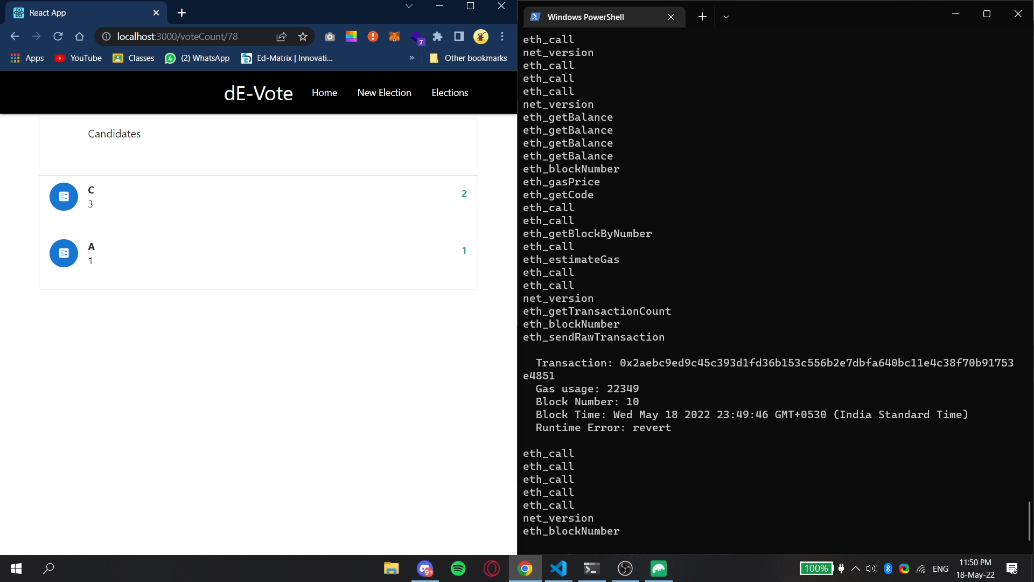

**CHAPTER 7**

**CONCLUSION & FUTURE SCOPE**

**7.1 CONCLUSION**

With dE-Vote as a tool to cast votes which is decentralized, we overcome various problems faced from the present voting system. Switching to this type of voting makes the whole election process transparent and tamper-free. This helps in arriving at a democratic result whilst implementing blockchain technology.

**7.2 FUTURE SCOPE**

The world now knows Blockchain can be used only in crypto currency which takes time to make them understand that it is a method which can be implemented to make use of its capabilities like a block cannot be duplicated every data which is used is kept track on point.

Blockchain has scope in fields like cybersecurity,digital currencies,supply chain management,world trade,forecasting,cloud storage.

Blockchain is just now scratching its surface of where it can be used. These implementations will happen in the near future.

**7.3 REFERENCES**

* Ethereum documentation: <https://ethereum.org/en/developers/docs/>
* Truffle framework documentation: <https://www.trufflesuite.com/docs/truffle/overview>
* Javascript: <https://www.codecademy.com/learn/introduction-to-javascript>
* ReactJS: <https://www.codecademy.com/learn/react-101>